Chapter 17 Written

**Written:**

**17.1:**

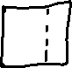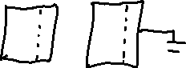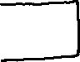

**17.2:**

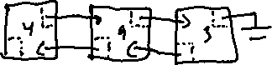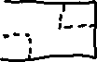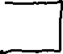

**17.6:**

